AI ASSISTED CODING

LAB-14.4

NAME:swaranjith reddy thatipalli

ENROLLNO:2403A52049

BATCH:03

**TASK-01:**

Create a Responsive Web Page Layout

**PROMPT:**

Generate a basic webpage layout which include header, main content ,footer also add CSS to make it more responsive in different screen sizes.

**CODE:**

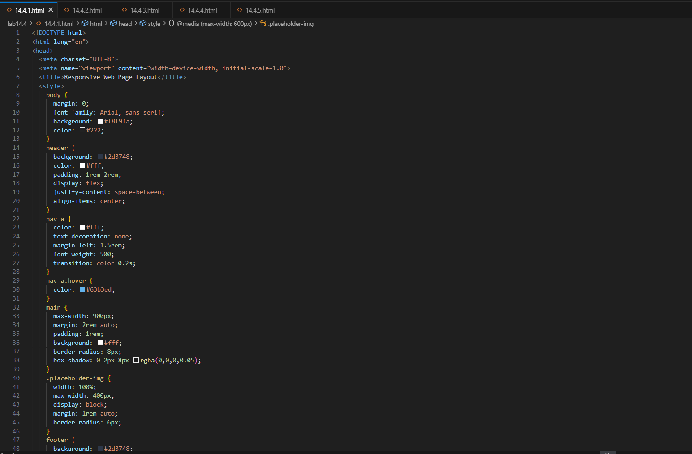

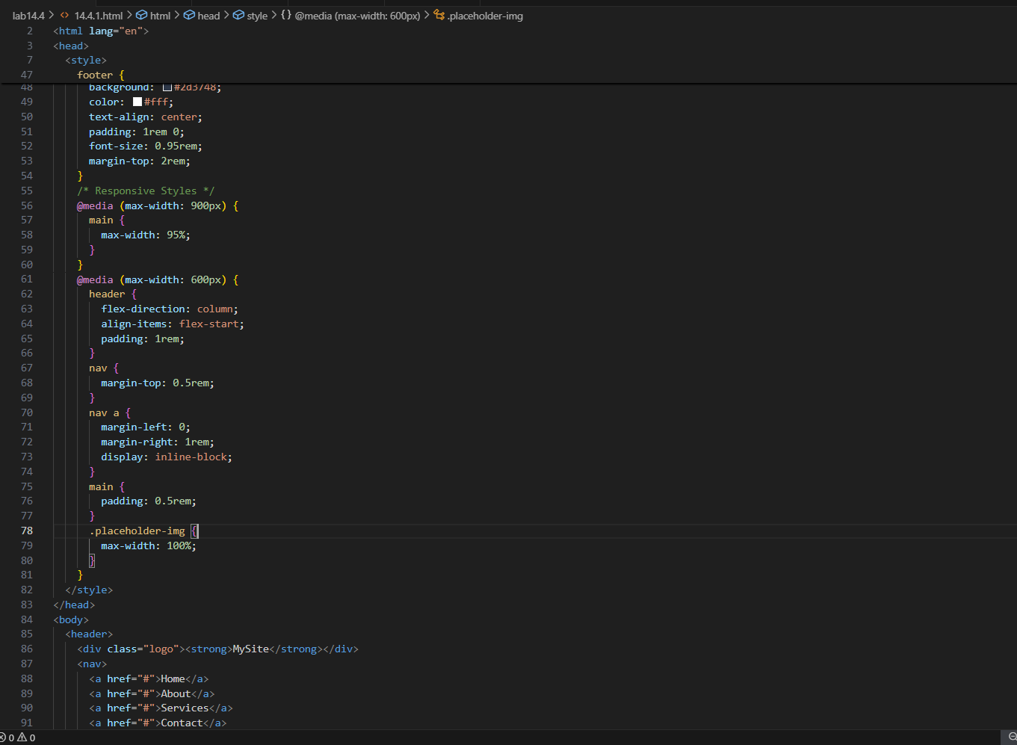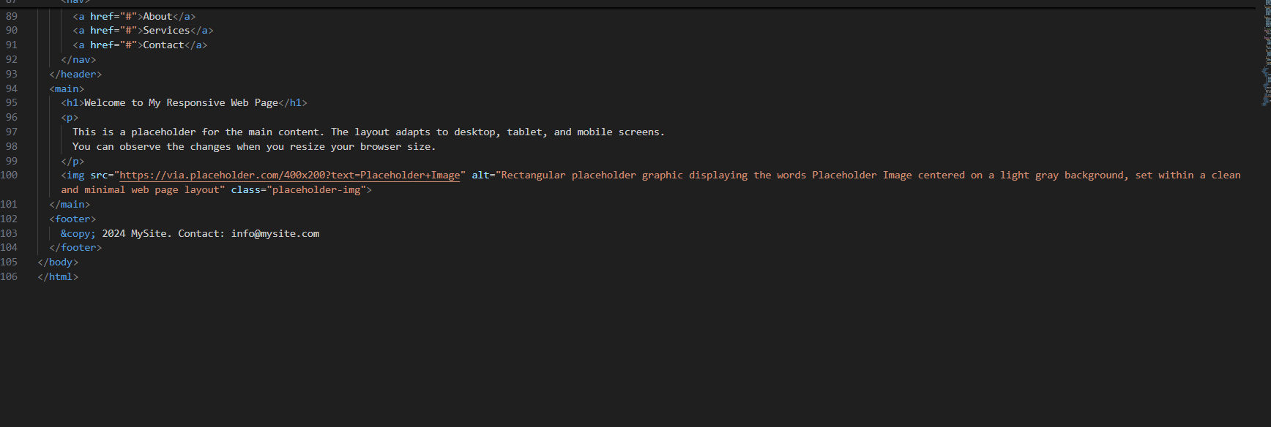

**OUTPUT:**

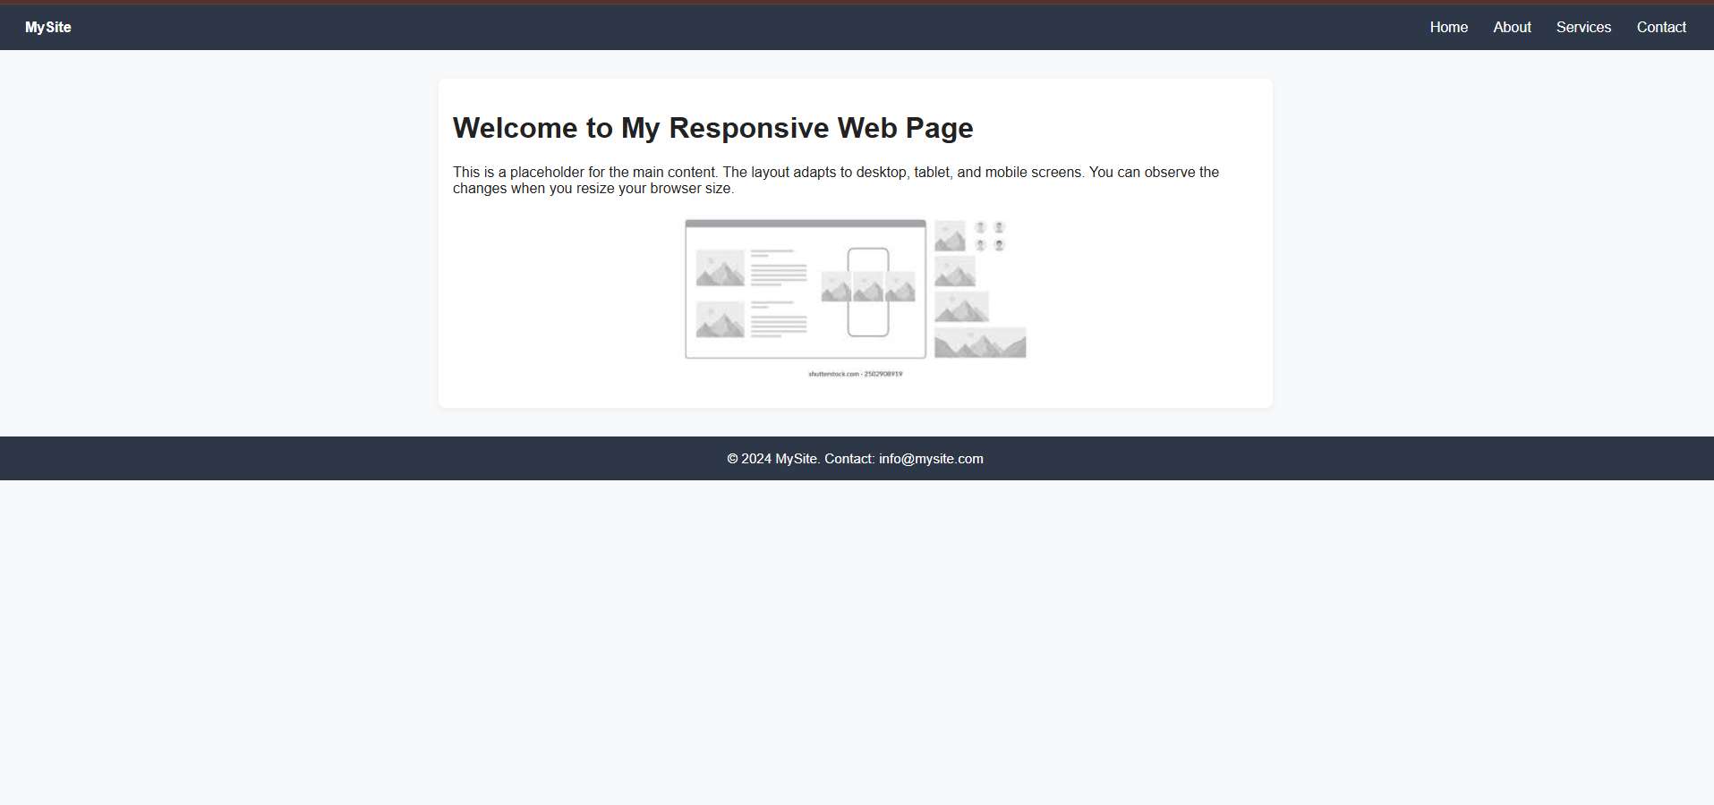

**OBSERVATION:**

The AI generated the webpage in an efficient way and it also included all the elements what we have instructed to it. It included the header section , body section and also the footer section.

**TASK-02:**

Interactive Button with Java script.

**PROMPT:**

Create a button on the webpage then use java script to display the popup alert message “Button clicked” when the button is clicked.

**CODE:**

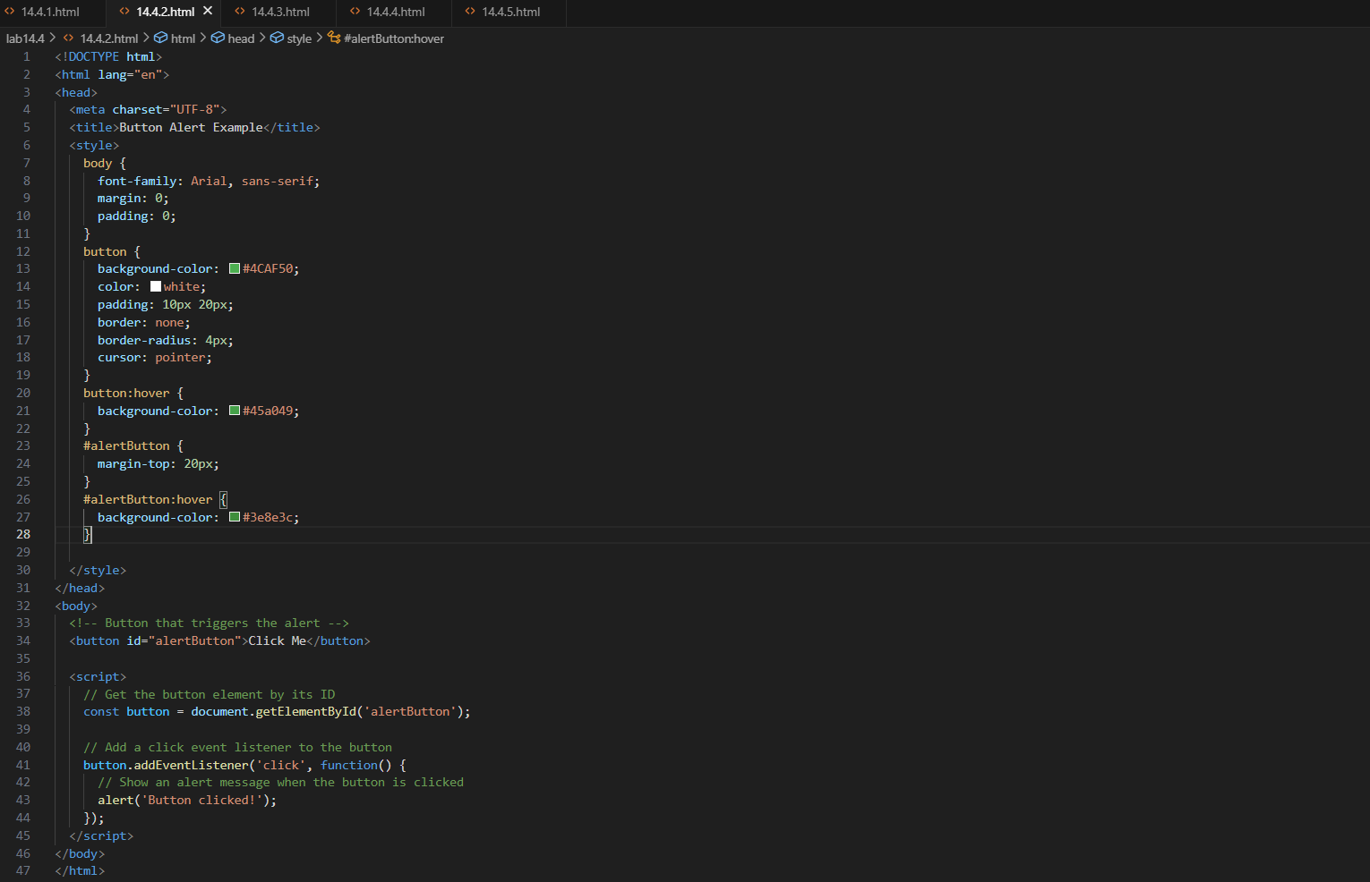

**OUTPUT:**

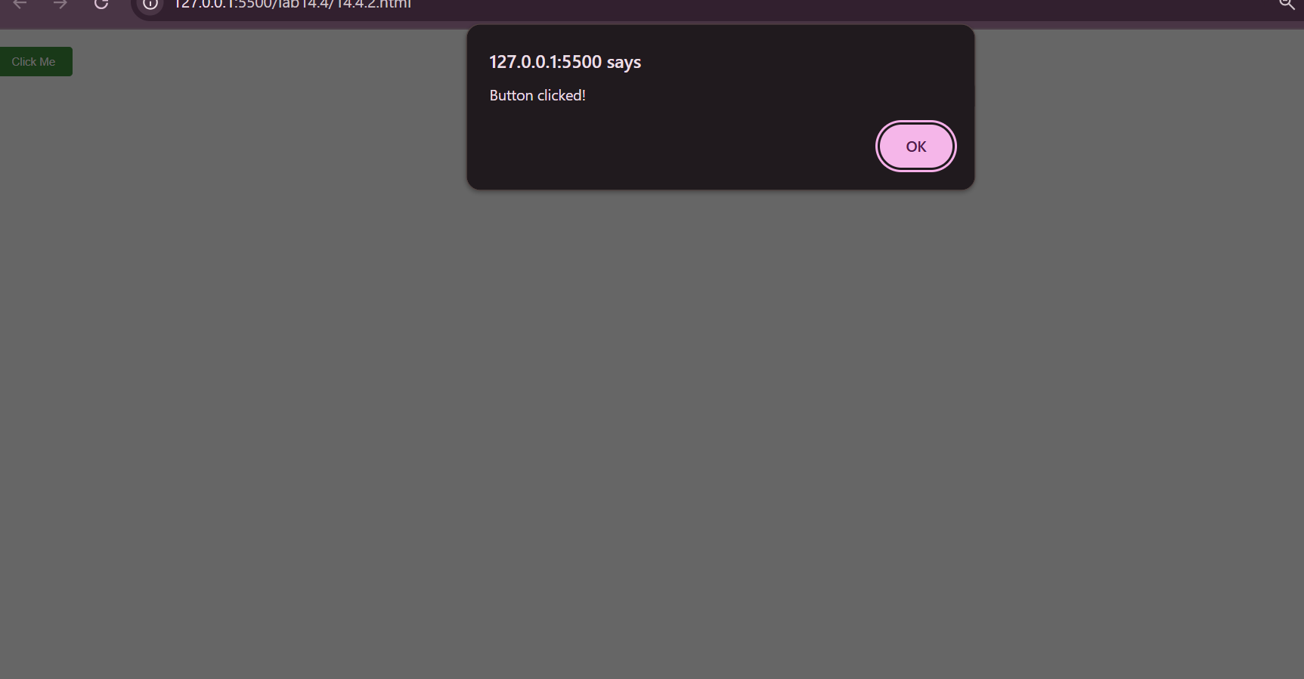

**OBSERVATION:**

The code generated by the AI which shows the popup message when the button is clicked.

**TASK-03:**

Form with Validation.

**PROMPT:**

Generate a form which accepts the details like name, email ,message use java script to validate the correct format and display the error messages if the required field is empty after completion of filling the data then it should display the message “Form submitted Successfully” on clicking the submit button.

**CODE:**

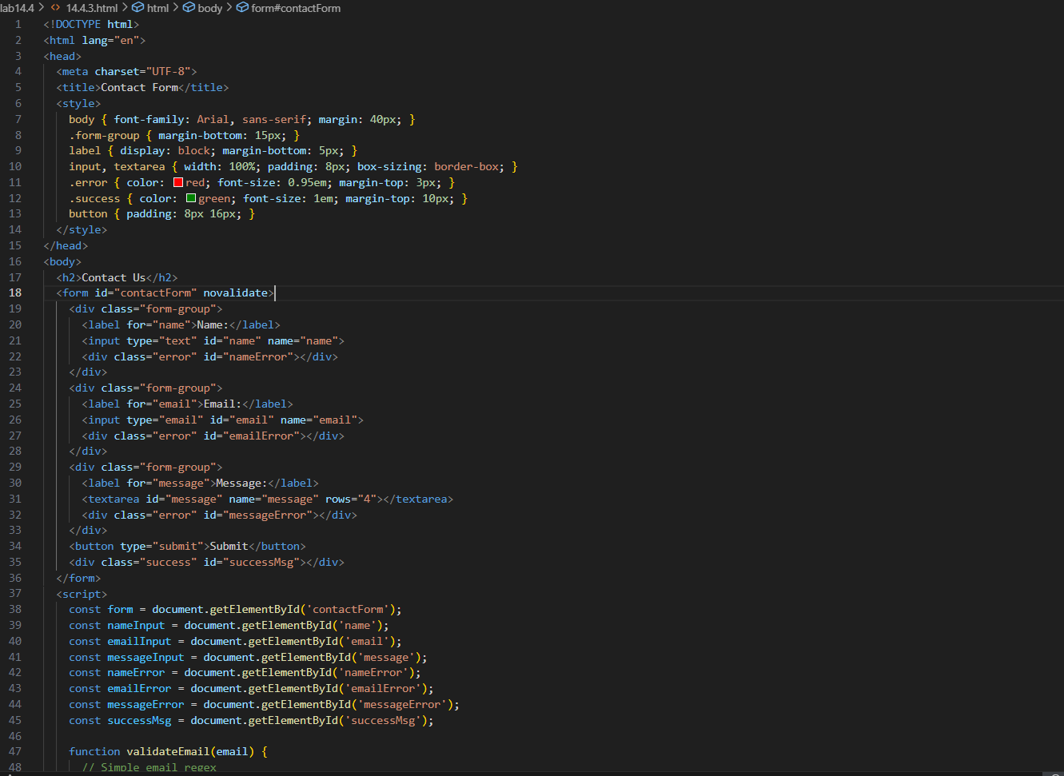

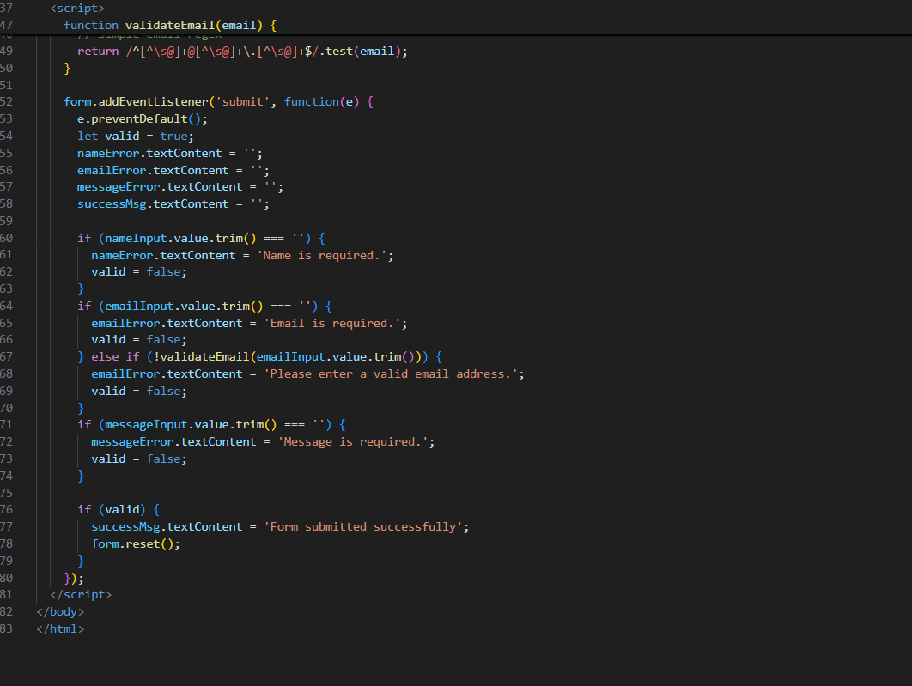

**OUTPUT:**

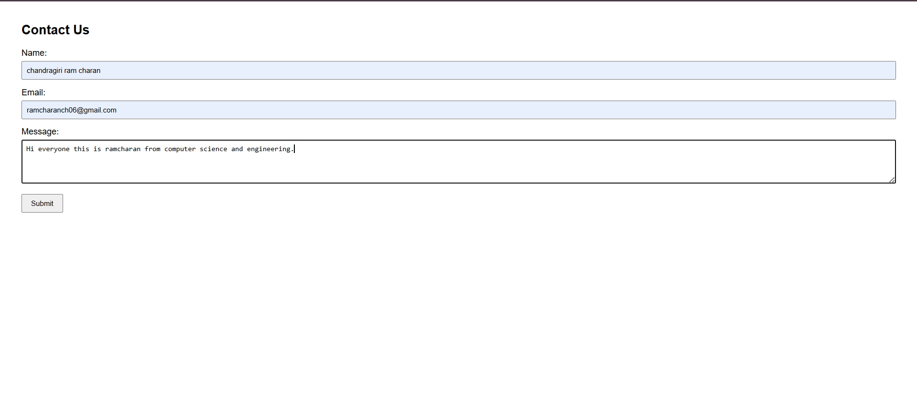

**OBSERVATION:**

From the code given by the AI we observed that it accepts the details such as name , email and a message if the required field is not filled it displays the error message.

**TASK-04:**

Dynamic content Generation

**PROMPT:**

Generate the html code which consists of list of items and the buttons add item and remove item then by using java script make it dynamic to add the item when clicked on add item and remove the item if remove item is clicked.

**CODE:**

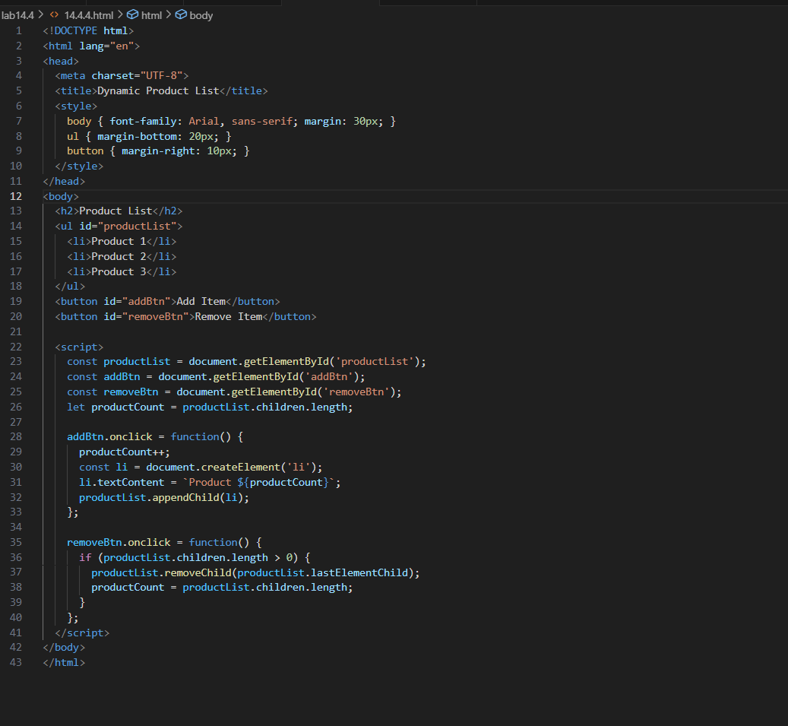

**OUTPUT:**

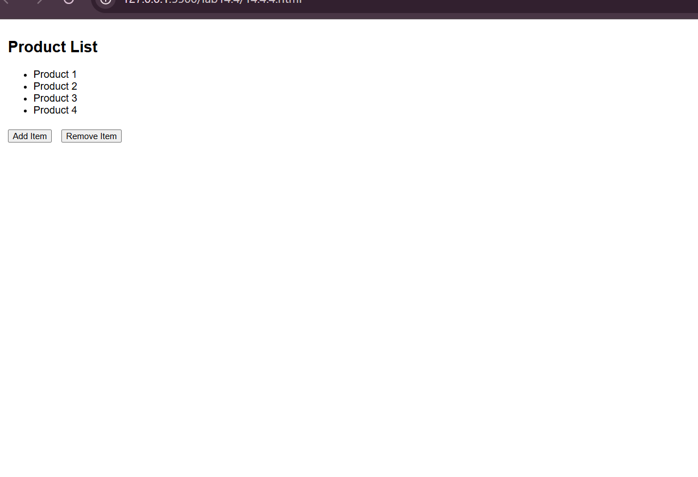

**OBSERVATION:**

The AI generated the code which contains the list of product names and it has the buttons add item and remove item which works in the dynamic way.

**TASK-05:**

Styled Modal Popup.

**PROMPT:**

Generate a modal popup which opens when we click the button which is present on the web page use CSS to style it in an impressive way also include the hide button which hides the modal popup.

**CODE:**

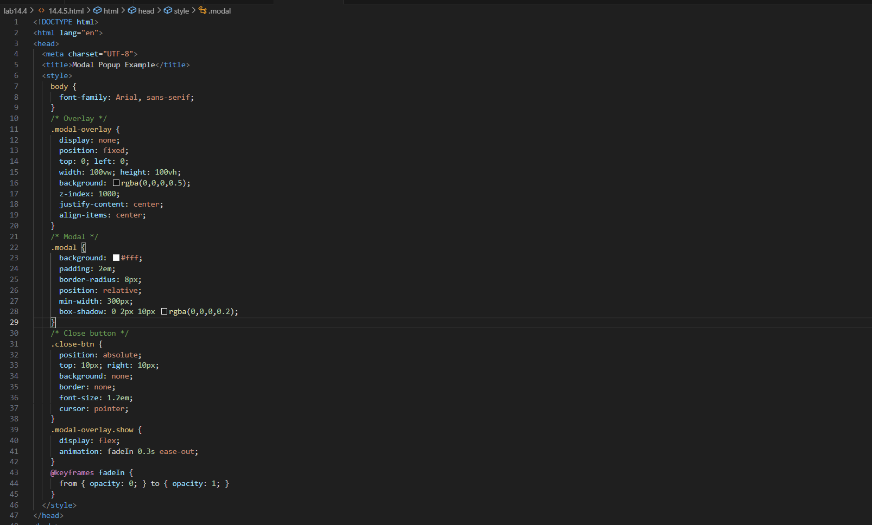

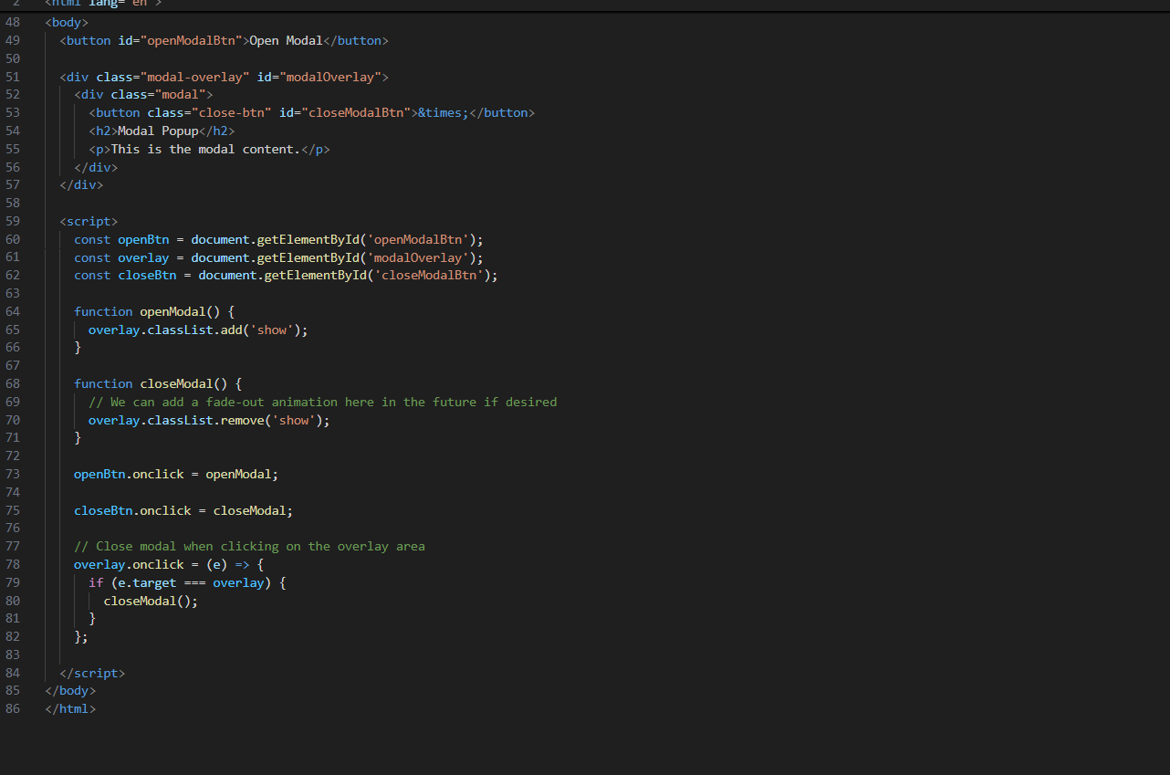

**OUTPUT:**

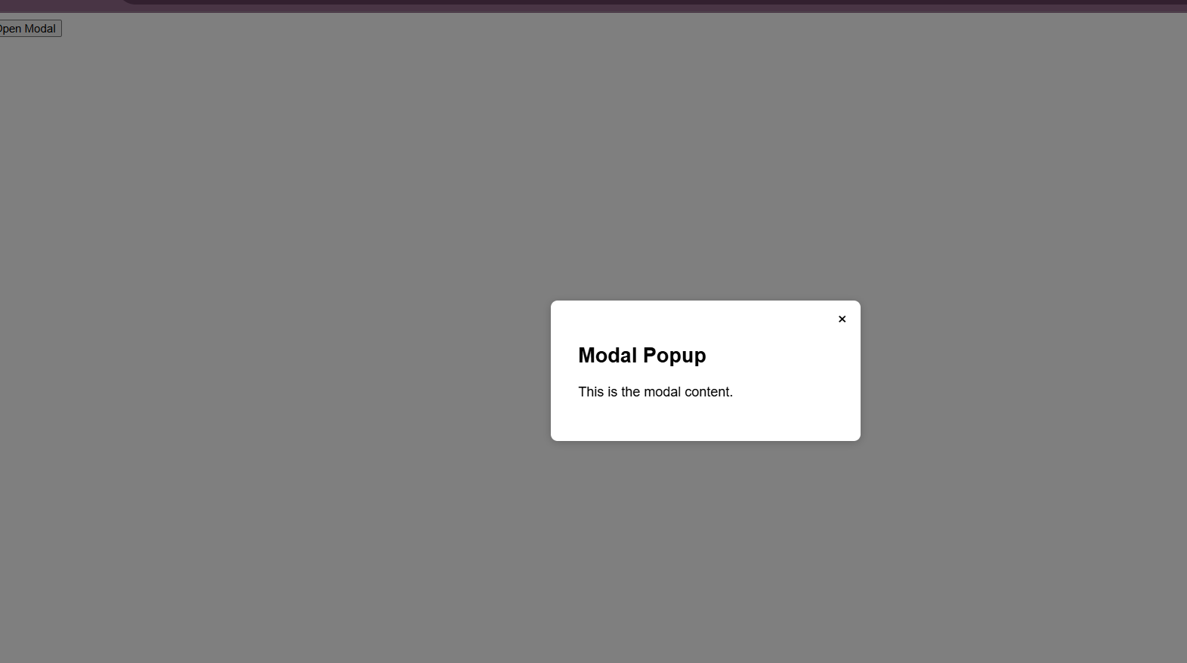

**OBSERVATION:**

The code generated by AI contains a button which displays a modal popup by clicking on it . the AI styled the modal popup in an impressive way.